# 4 Testing

Testing is an **extremely** important component of most projects, whether it involves a circuit, a process, power system, or software.

The testing plan should connect the requirements and the design to the adopting test strategy and instruments. In this overarching introduction, given an overview of the testing strategy. Emphasize any unique challenges to testing for your system/design.

## Unit Testing (Nick)

What units are being tested? How? Tools?

For both our backend & frontend system we will be using Jest for unit testing. Jest is a javascript testing framework, and since we’re using both javascript & node.js it will be perfect for our team. Jest will allow us to write modular tests on all functional parts of both frontend and backend.

## Interface Testing (julia)

What are the interfaces in your design? Discuss how the composition of two or more units (interfaces) are being tested. Tools?

We will be creating a website application to display and analyze our sensor data. We will be testing this user interface with the Postman tool. This allows us to properly test our website even if a sensor is not connected.

## Integration Testing (Devon)

What are the critical integration paths in your design? Justification for criticality may come from your requirements. How will they be tested? Tools?

As our project develops and we integrate more parts into the project, we will test each component. As the project grows, we will need to perform system integration testing, testing the system as a whole to make sure all parts are working together.

## System Testing (Jake)

Describe system level testing strategy. What set of unit tests, interface tests, and integration tests suffice for system level testing? This should be closely tied to the requirements. Tools?

Complete end to end testing will have to wait until all the integration and interface testing has finished, since our sensors and camera will have to update the web server we will be using. I don’t exactly know what tools can be used to test this, it must be more of a “trial and error” testing process, since any error could be any number of causes.

## Regression Testing (Sarah)

How are you ensuring that any new additions do not break the old functionality? What implemented critical features do you need to ensure they do not break? Is it driven by requirements? Tools?

We are going to be using an agile approach to testing our project, and as such as we go along and add new features we will make sure that they do not break what was already there. On the chance that they do break something, that gives us a chance to learn, grow and change what we have. We can make sure new functionality does not break, and meets our requirements, by doing Regression testing when the new feature is added. This will be going through our website and making sure the functionality that we expect to happen works. That would entail coordination with the hardware implemented like the cameras, and the watering system.

We need to make sure that anything that coordinates with the hardware does not break. As stated earlier this will be the camera, watering system, lighting timer. We also need to make sure that the website does not crash and can be accessible at all times by the user.

## Acceptance Testing (Bryanna)

How will you demonstrate that the design requirements, both functional and non-functional are being met? How would you involve your client in the acceptance testing?

We will make sure to have tests for all aspects of our design to make sure that all requirements are being met. This means we will do various kinds of tests to ensure that all of the functional requirements we have are working properly. So we will want to test that all our sensors and interfaces are working accurately. We will want to go back and see if everything we agreed to be in our project is actually there. Typically this is done to make sure the contract requirements are met, but in our case we don’t have a client so we will go back to what we finalized as our main project and goal and make sure that what we decided on is up and running.

## Security Testing (if applicable)

This is not applicable at this current time for our project

## Results (jasen)

What are the results of your testing? How do they ensure compliance with the requirements? Include figures and tables to explain your testing process better. A summary narrative concluding that your design is as intended is useful.

We will measure our results as parts of a modular system. So long as the basic communication between each subsystem meets the requirements that we decide upon, we will consider that subsystem to function properly.

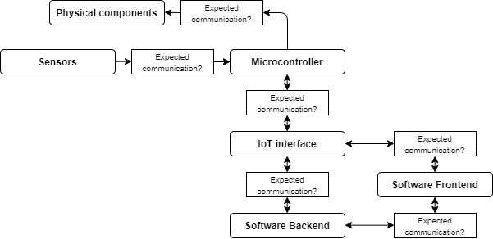

Of course we want to make sure that the system as a whole functions as expected as well, so broader scale testing will also be measured against the benchmarks that we determine.